Programming for Game Design Final Project Plan
Project description
A procedurally generated 2D side-scroller ‘sandbox’ with different elements like plants or animals that react to their environments. For example, plants that grow with water or creatures that run away from the player. Additionally, the player will be able to interact with the world through the cursor or other hardware inputs such as the keyboard or the microphone. Since it’s a 2D side-scroller there will be different layers on screen (foreground, middleground, background) with darker shading as it nears the background to create an illusion perception of depth.
Prompt
I am beginning to plan my final project in an intro-level high school coding class. The final project will be written in Processing language.
Please review my project proposal and give me a comprehensive list of all the major coding concepts and techniques that I will likely need to use (for example, iterating through an array with a for loop, PImages, objects, etc).
What are probably the trickiest or most complicated concepts for this type of project as a beginner programmer?
Can you help me structure an ordered list of how to roughly tackle this from beginning to end? For example, if I was coding pong, I might want to start by creating players that can move back and forth with KeyPressed, then focus on creating a ball, then implementing a way to have the ball bounce off the paddles, etc
ChatGPT’s estimation of project requirements
🧠 Major Coding Concepts & Techniques You’ll Likely Use
Core Processing Fundamentals
1. Variables & Data Types – store positions, sizes, colors, health, etc.
2. Conditionals (if, else) – for reactions like “if plant gets water, grow.”
3. Loops (for, while) – iterate over arrays or grids for terrain or entities.
4. Functions – organize code (e.g. update(), display(), grow() for plants).
5. Random() – generate procedural elements (plant placement).
6. Images & Colors (PImage, tint(), fill()) – for sprites, background layers.
7. Keyboard & Mouse Input – player movement, clicking/interacting, etc.
8. Microphone Input (AudioIn) – advanced interaction via volume or frequency.

Object-Oriented Programming
9. Classes & Objects – define Plant, Animal, Player, Tile, etc.
10. Encapsulation – keep each object’s behavior self-contained.
11. Arrays or ArrayLists of Objects – store all entities and iterate through them.
12. Inheritance (optional) – shared traits (e.g. both plants and animals are Entity).

Environment & Procedural Generation
13. Noise (noise()) – create smooth terrain and natural randomness.
14. 2D Arrays / Grids – represent world tiles (grass, dirt, water).
15. Parallax Scrolling – multiple background layers moving at different speeds.
16. Camera / Viewport System – move the “window” as the player walks.
17. Physics Basics – gravity, jumping, simple collisions.

Interaction & Simulation
18. Collision Detection – player touching terrain, animals, or plants.
19. Simple AI / Behavior Rules – animals that run away, plants that react.
20. Timers / Frame Counting – for growth cycles or animations.
21. Sound Input & Output – microphone reactions, sound effects.

Polish & Optimization
22. Sprites & Animation Frames – for creatures or player movement.
23. Layering & Depth Sorting – adjust colors and rendering order for perspective.
24. Performance Management – avoid lag by limiting object counts, off-screen rendering.

⚙️ The Tricky / Complicated Parts (for a beginner)
1. Procedural generation using Perlin noise – understanding how to make natural terrain.
2. Camera / scrolling system – syncing world movement vs. player movement.
3. Collision detection – especially when combining with scrolling worlds.
4. Object interactions – e.g., plants detecting nearby water, animals reacting to player.
5. Organizing code structure – juggling multiple classes and lists without confusion.
6. Microphone input – Processing’s Minim or Sound library adds complexity.

🪜 Suggested Order to Tackle the Project
Step 1: Foundation
1. Create a simple window and draw a static terrain (rectangles or lines).
2. Implement player movement – left/right walking and simple gravity.
3. Add a camera system – so the player appears centered while world scrolls.

Step 2: World & Environment
4. Generate terrain procedurally using noise().
5. Add a sky, ground, and background layers with parallax scrolling.
6. Experiment with color shading by depth (foreground lighter, background darker).

Step 3: Entities
7. Create a Plant class – grows over time or when watered.
8. Create an Animal class – simple wandering and “run away from player” behavior.
9. Store multiple plants/animals in ArrayLists and iterate through them each frame.

Step 4: Interaction
10. Implement cursor or keyboard-based interaction – clicking or pressing keys to trigger events.
11. Add microphone input (optional, later) – detect volume or noise to make reactions.

Step 5: Polish
12. Add visual layers and tinting for depth illusion.
13. Add simple animations or sprite changes (optional).
14. Optimize – clean up unused objects, prevent off-screen processing.
15. Finalize with UI or minimal goal (e.g., grow a certain number of plants).

Notes
Day 1 - Nov. 4, 2025
What I worked on
- Get basic character movement working
  - I created a Meeple class and got user inputs working with my library, MR KEYBOARD!!!
- Began work on procedural generation
  - I created a World class that will help manage the game world and a Terrain class that will act as the procedurally generating floor.
- Created other basic classes for future use
  - The Displayable class (later removed with an interface taking its place)
    - Static class
      - Bush
      - Tree (unfinished) (later removed)
    - Movable class (later renamed to Entity)
      - Interactible (later removed)
      - Meeple
  - Layer
    - This is for the layer rendering system that allows for foreground and background.
    - Responsible for rendering entities and static objects.
  - Environment
    - Responsible for the day-night cycle and other weather related things.
  - World
    - Responsible for the game world.
  - Terrain
    - Responsible for the floor.
Problems
- Performance issues: the layering system currently requires the World class to submit dynamic items each frame, slowing down the sketch (slightly noticably)
Next class
- Fix performance issues
- Continue working on interactibles (add a dog? Or something to test it)
- Work on Tree
Day 2 – Nov. 6, 2025
What I worked on
- Optimizations to the rendering system
  - Instead of submitting entities each frame and removing the next frame, it now stores entities and removes them when dead.
- Edits to the Movable class (now called Entity)
  - I created the basic outline of the class
  - I added an incrementing ID (0 for first, 1 for second, etc.) system that may come in handy in the future.
- Created a flying dog (i.e., a circle) class as a test of the Entity class
Problems
- Making the dog move normally instead of orbitting the player
  - (I didn’t have enough time to fix it)
Next class
- Work on the dog: make it not orbit the player
  - Instead make it follow the player once the player leaves a 100 pixel radius
Day 3 – Nov. 10, 2025
What I worked on
- Fixed the dog. It’s now a flying dog that doesn’t sink into the floor
- Created a Particle and Particle System class for future use
  - Particle system origins can either remain stationary or attach to an entity. This is useful for particle effects such as dirt flying when the player walks on the ground.
Problems
- The particle system doesn’t seem to attach to entities properly
Next class
- Work on the particle system
Day 4 – Nov. 12, 2025
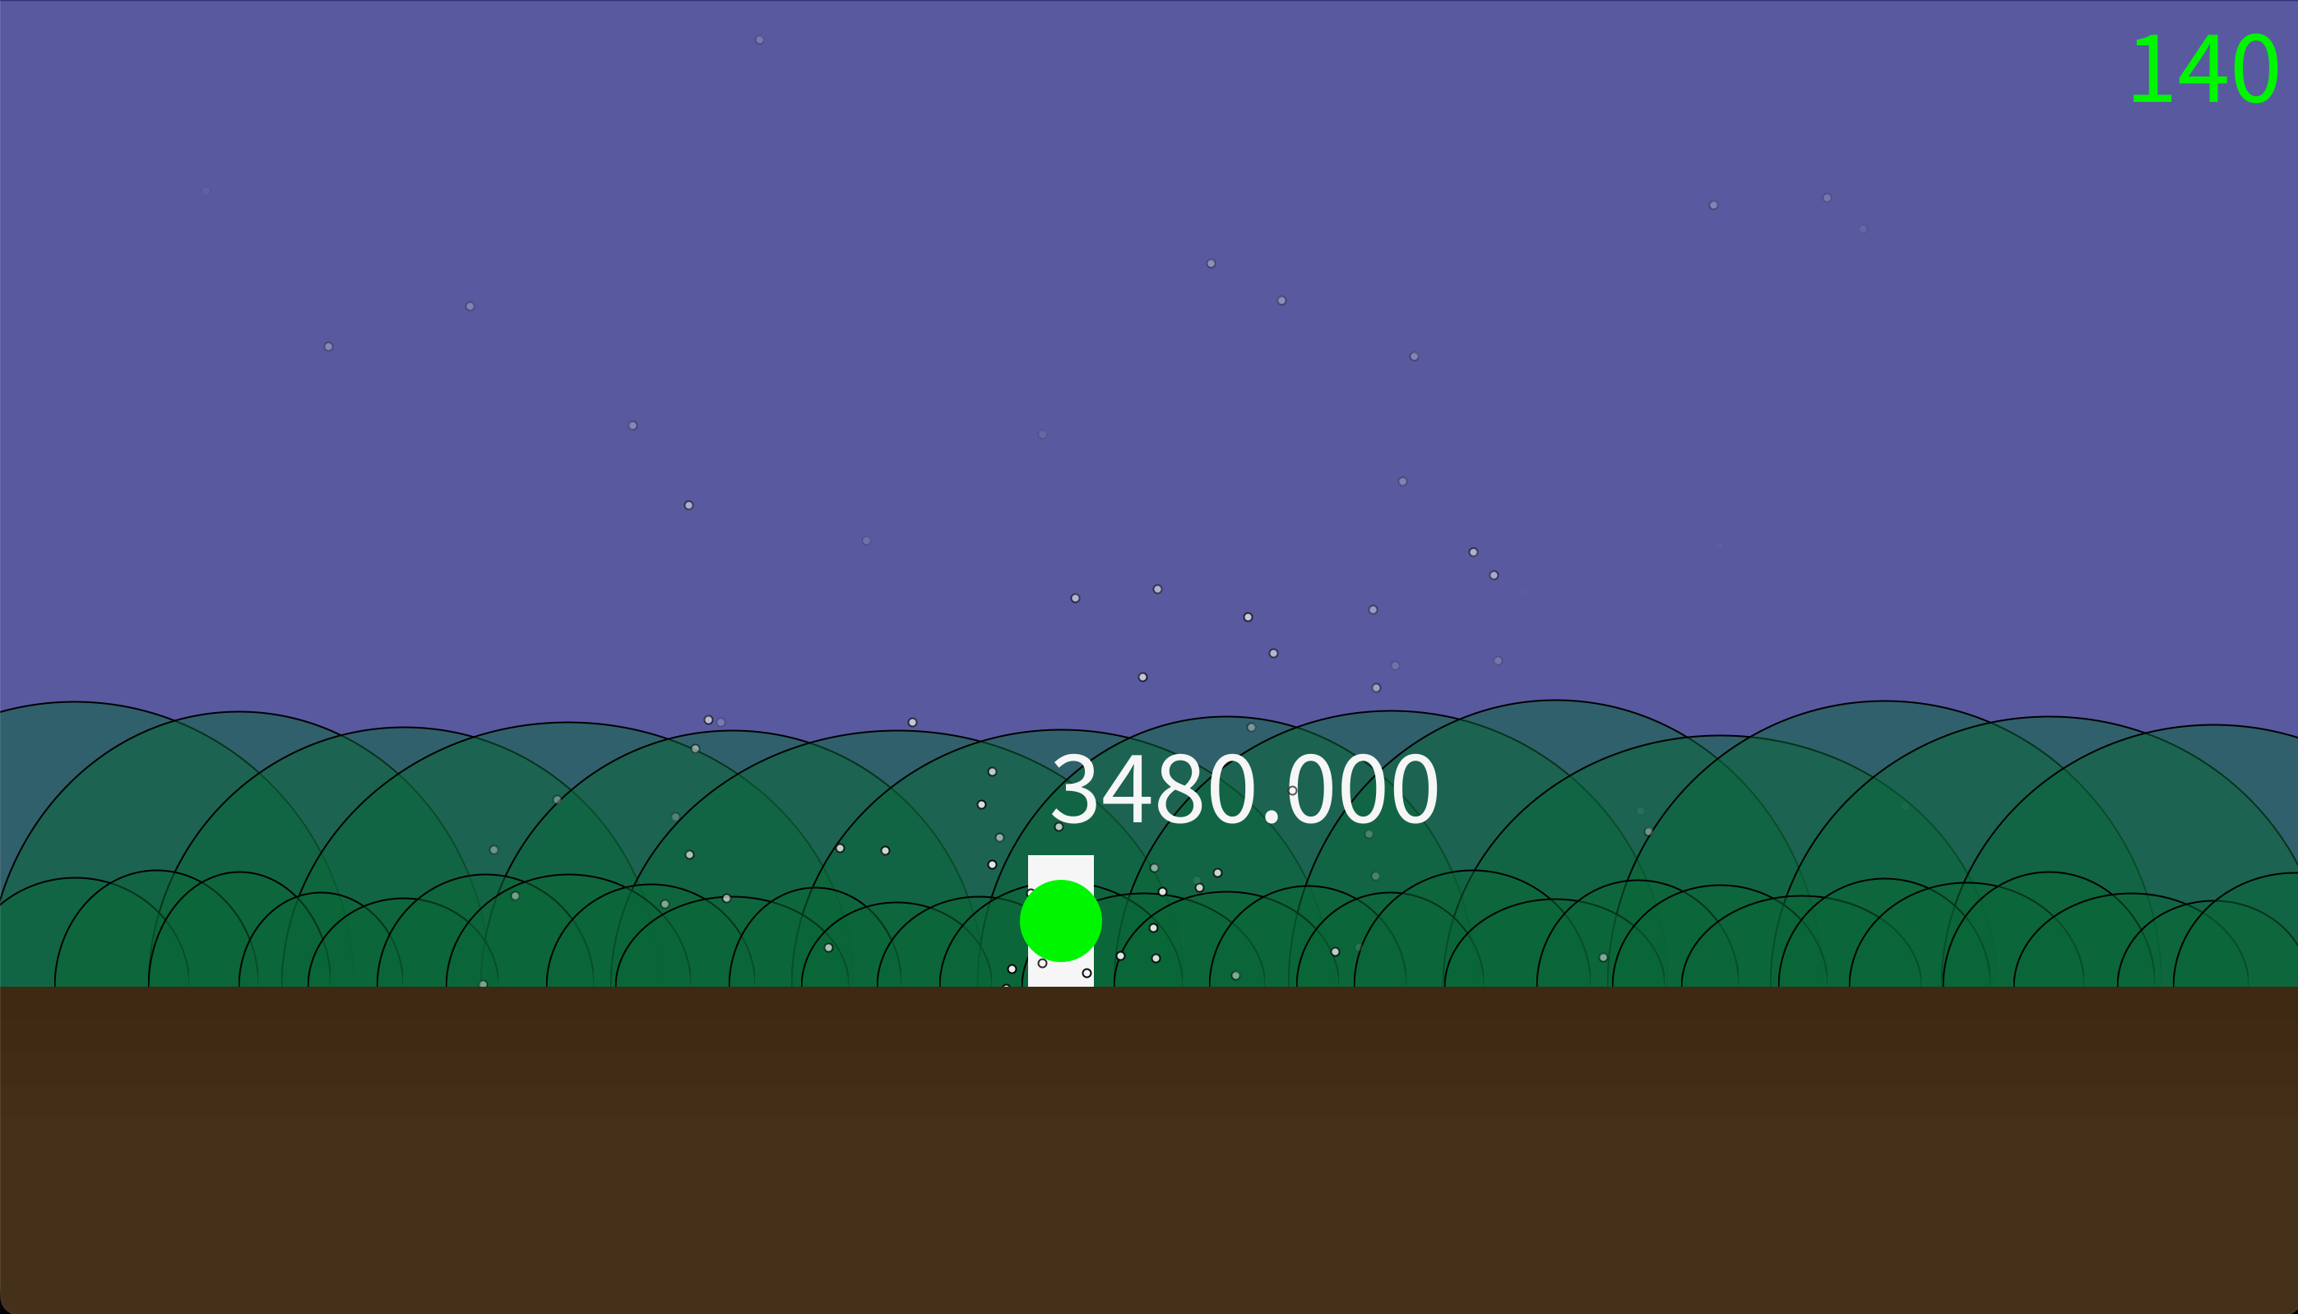
What I worked on
- Added a dirt particles that spawn when the meeple is on the floor and moving
  - As you can see in the image above, it is clearly scattering too far, but the basic concept is correct.
  - It now attaches corretly to the meeple.
- More optimizations to the program
Problems
- None
Next class
- Make the game do all sorts of crazy things (I realized this was too big of a scope for the time remaining so I later decided to create enemies and make it a winnable game)
  - Sandbox where anything is possible
  - Crazy stuff too

Day 5 – Nov. 14, 2025
What I worked on
- Created a Body class that each Entity must have. Bodies are responsible for physics like collisions, and entities are responsible for the kinematics (velocity, acceleration) as well as other state.
  - RectBody
  - CircleBody (later deprecated- it still exists but isn’t used and hasn’t been tested or updated as new features were added)
- Scaffolding for the attach feature where entities can attach onto other entities (later removed)
Problems
- SEVERE LAG ISSUES- Body seems to be lagging the entire game to a ridiculous extent
Next class
- Fix the lag issues
- Attach feature (later removed)
- One-way platforms (mario-style)

Day 6
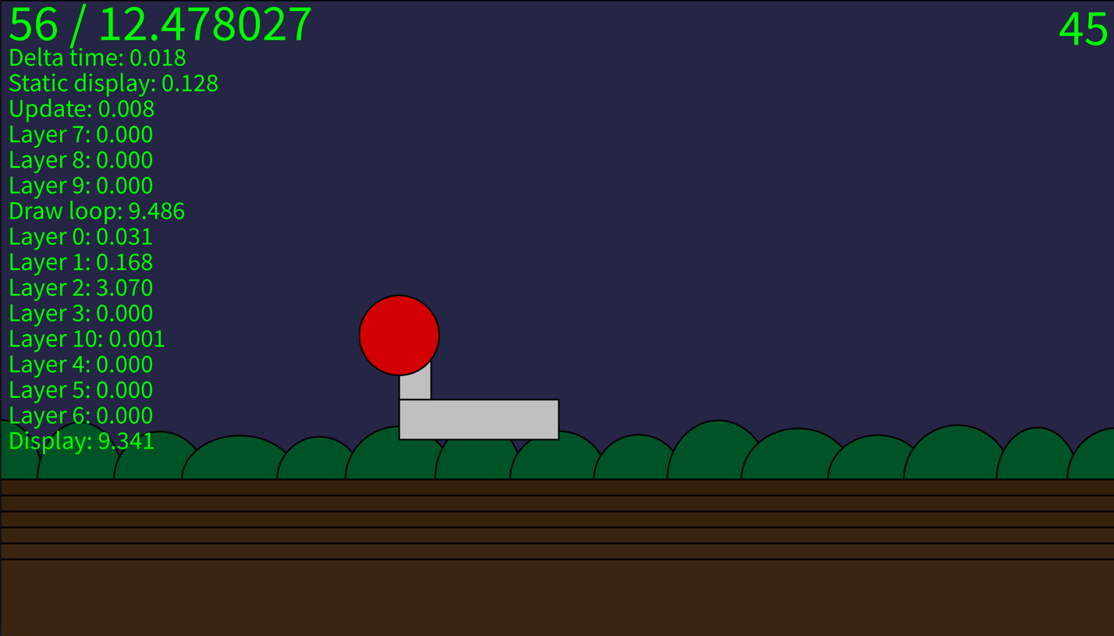
What I worked on
- Created a basic debug system that allows me to optimize the program and easily cathc parts of the program that are taking too long to run (see above).
- Added delta time: now, the game should run at the same visually seem to run at the same speed regardless of the frame rate
- Created a static class Collision and CollisionResult
  - Responsible for checking for collisions and returning collision data
- Added one-way platforms
  - These use Collision to check for collisions
  - In order for one-way platforms to work, the previous positions of entities must be known
    - This prevents entities from snapping to the platform when jumping up through it (under to over)
- Fixed lag issues
- Fixed bug where circle collisions didn’t work (I used the radius instead of diameter when calling circle())
- Removed the ‘cached rendering’ system for static items (not really cached, but whatever) which actually slowed down the program (drawing to a separate Pimage took longer than expected, leading to lag issues such as how each bush takes more than 1ms to draw, way too long for the number of bushes on screen at a time.
Problems
- One-way platform collision doesn’t work as expected (not only top collisions but also side-on collisions)
Next class
- Fix one-way, mario-style platforms

Day 7 – Nov. 20, 2025
What I worked on
- Fixed the one-way platform collisions
  - They’re one-way, meaning you can phase thru them but if you jump on them, you’ll remain on top
  - Basically mario style
- Created a basic Enemy class
- Created an enemy called Roofus
Problems
- None
Next class
- Make Roofus follow the player

Day 8 – Nov. 24, 2025
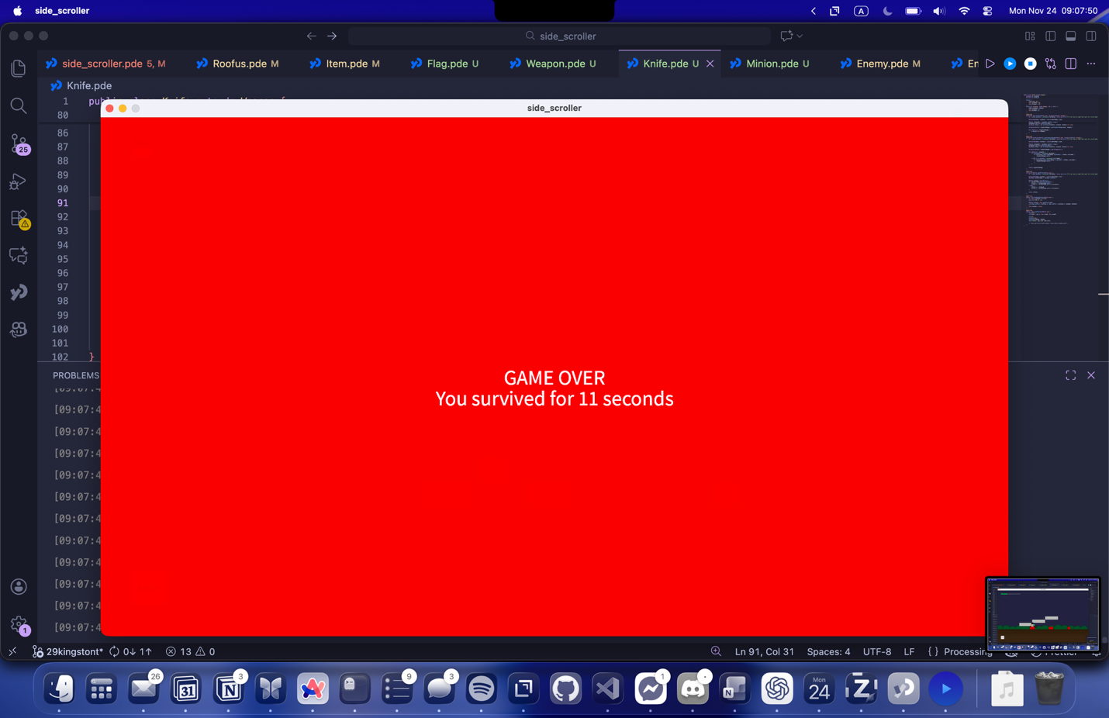
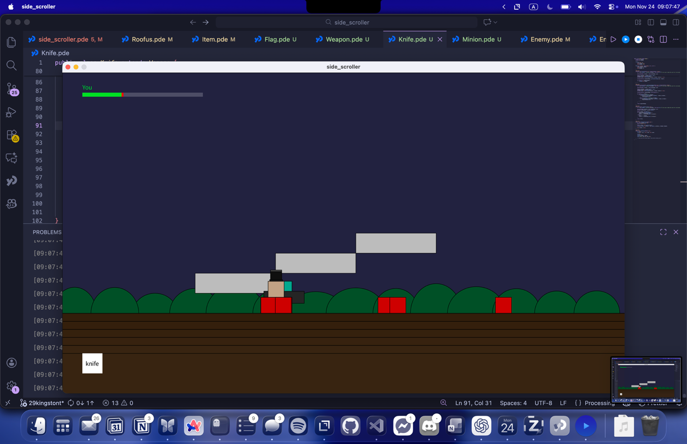
What I worked on
- Roofus
  - Made roofus follow the player
  - Made roofus spawn smaller ‘minions’ every attack
- Minion
  - Follows the player
- Created a Weapon class
  - Created weapons like knife that enemies and players can wield and use
- Added HP for all entities
- Added an animated health bar for the player at the top of the screen
- Added a gameover screen
Problems
- None
Next class
- Add ‘flags’ or collectables. 15 to win or something similar
  - Collectable interface?

Day 9 – Nov. 26, 2025
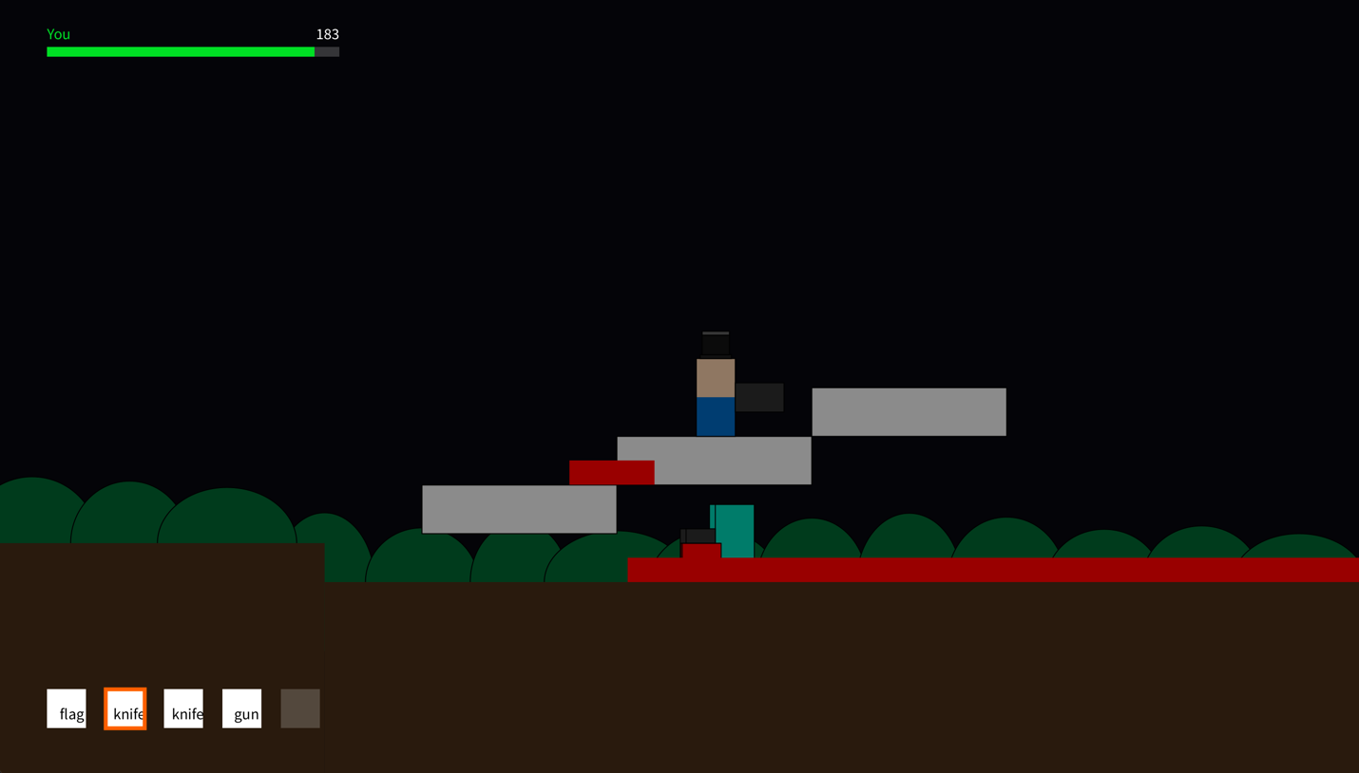
The red stuff are the dysfunctional bullets
What I worked on
- Added an item menu that can be used with the keyboard numbers 1 through 5
- Created a disfunctional Gun class and Bullet class
- The terrain now varies in height!!
  - This works by picking a number from a set of {-1, 0, 1} and multiplying it by the BLOCK_UNIT which is 40.
  - If the height goes over a certain amount, there will only be the option of decreasing or remaining at the same height {-1, 0}
    - Same for if the height goes below a certain amount
Problems
- None
Next 2 classes
- Make bullets shoot properly
- Add the reload feature for guns
- Add ‘flags’ or collectables. 15 to win or something similar
- Work on procedural generation of platforms

Day 10 – Dec. 2, 2025 (IT’S DECEMBER!!!!!!!!!)
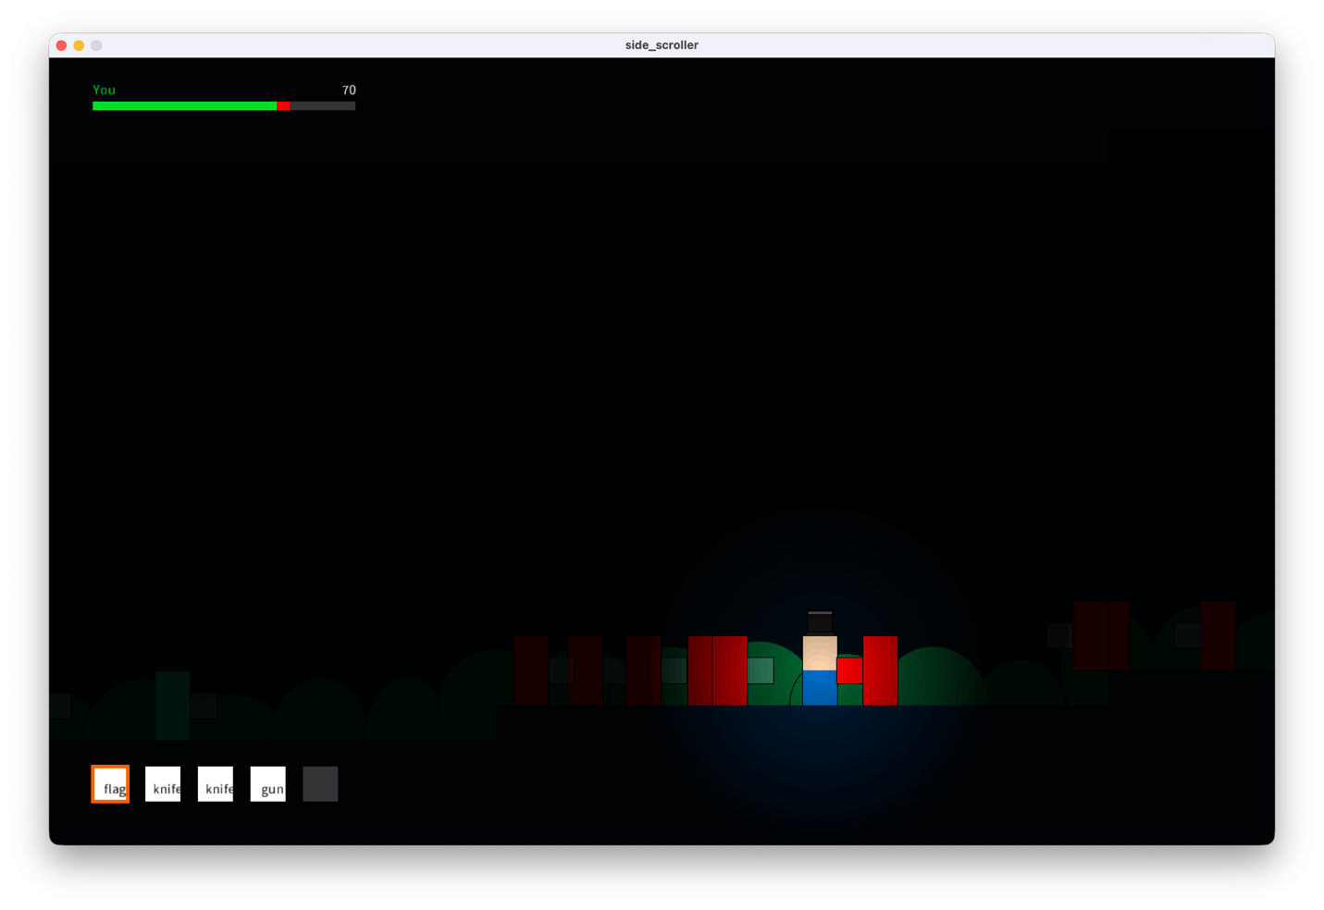
What I worked on
- Massive optimizations
  - A chunking system, frozen chunks, and displayed chunks
- A light source that follows the player
  - The Environment class is responsible for this. I created a glow() method that takes in a RectBody among other parameters and makes it glow for one frame (it’s called every frame in the update loop).
  - I’m very proud of this effect, so here’s an in-depth explanation of how I did it 🤣. To achieve this effect, I created two PGraphics variables: lightMask and darknessFilter:
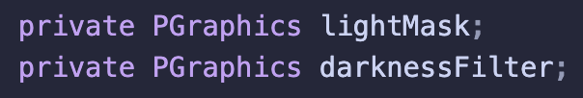
  - Then, in Environment’s update loop, I fill the lightMask with a background of 0-255, where 0 is complete brightness and 255 is complete darkness (it’s inverted because the darkness filter will be filled black. Applying a mask to a PGraphic works by using the grayscale value as the alpha for each pixel. This means a grayscale of 0 means that the black will have an alpha of 0, or in otherwords, it’s transparent, thus representing daytime. A grayscale of 255 means that the black will have an alpha of 255, meaning it would be complete darkness, and nothing will be seen.)
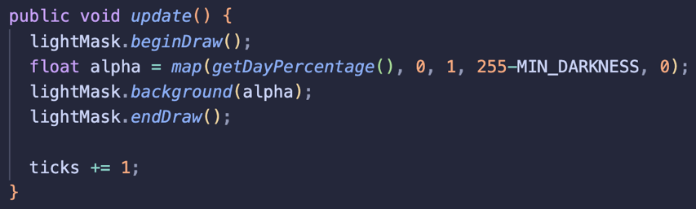
  - 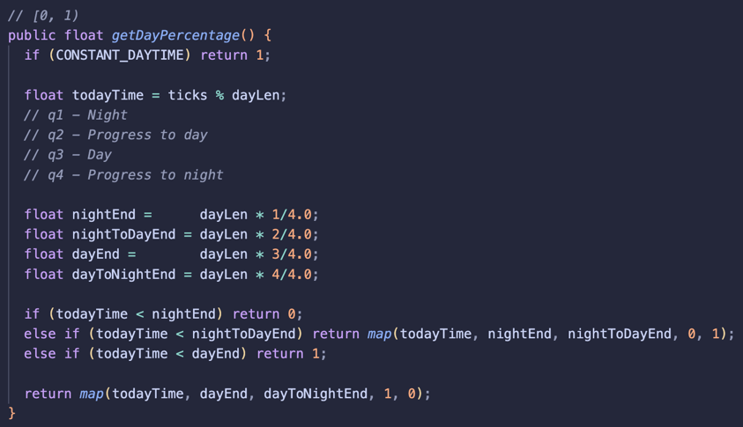
  - Then, in glow() concentric circles are drawn onto lightMask where the center of the RectBody target has a grayscale value of 255, or white, meaning this is the center of complete brightness. The grayscale value decreases as it gets away from the center, creating a glow effect.
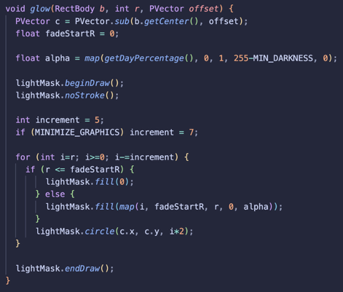
  - Finally, in displayFilter(), the lightMask is applied to darknessFilter and drawn onto screen.
  - 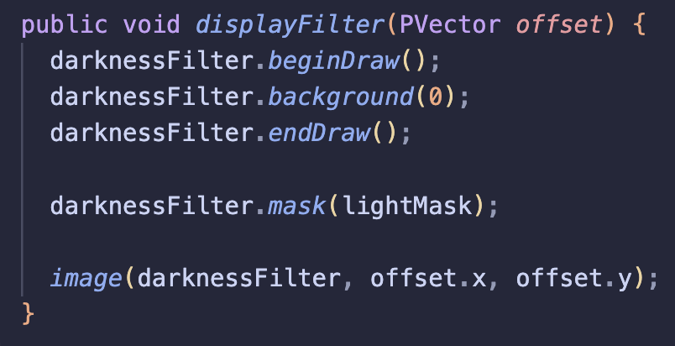
- There is now an ‘upside down’ that you can flip to
  - This was a MAJOR change. There is now a rightsideUp terrain and an upsideDown terrain, all entities can now be either rightsideUp or upsideDown, and platform collisions had to be modified.
- To make sure the player doesn’t flip to avoid enemies, there’s severe fall damage when the player flips
  - Unless, the user falls on a Trampoline (subclass of the Platform class)
- Guns now reload
Minor problems
- Bullets spawn under the gun
Major problems
- The player phases through certain platforms (trampolines) when velocity is fast enough
Next 2 classes
- Add ‘flags’ or collectables. 15 to win or something similar
- Work on procedural generation of platforms
- Fix trampolines
Day 11 – Dec. 4, 2025 (T-21 days)
What I worked on
- Fixed trampolines and make them procedurally generate
- Added the ability for the Meeple to collect items
Major problems
- None
Next 2 classes
- Make flags procedurally generate
- Make different types of enemies
Day 12 – Dec. 8, 2025 (T-17 Days)
What I worked on
- Created an enemy that follows the player and begins a countdown before exploding
  - Damage dealt is based on the player’s distance from the center of the enemy
  - On explosion, the enemy dies
- Instead of just one type of enemy spawning, multiple types can now be spawned from a list of spawnableEnemies. Each have a random chance of occurring
- Enemies now randomly spawn not just in the rightside up but also the upside down
- Flags now procedurally generate
Major problems
- None
Next class
- Make 2 types of flags: upside down and rightside up ones?
  - Or any other game mechanic that forces the player to travel between the two sides
- Make flag items stackable
- Add a win condition where the player collects some number of flags to win
Day 13 – Dec. 12, 2025 (T-13 Days)
PRESENTATIONS!
Nothing got done today.

